H.T No
Regulations:
A15

Sreenidhi Institute of Science and Technology
(An Autonomous Institution)
Code No: 5B515 Date: 27-Oct-2020 (AN)

B.Tech III-Year I-Semester External Examination, October - 2020 (Supplementary)
Kinematics of Machinery (ME)

Time: 2 Hours Max.Marks:75

Note: a) No additional answer sheets will be provided.
b) All sub-parts of a question must be answered at one place only, otherwise it will not be valued.
c) Missing data can be assumed suitably.

ANSWER ANY 5 OUT OF 8 QUESTIONS. EACH QUESTION CARRIES 15 MARKS.

1. | a) | Define the pair. Explain any two lower pairs. | [8M]
 | b) | Differentiate the machine and structure. | [7M]
2. |  | In th In the mechanism shown in Figure 1 the slider moves uniformly vertically downloads at 5m/sec. The various dimensions of the link are AB = 15cm, AC = 10cm and CD = 20cm. Determine: | [15M]
  (i) Linear velocity of slides links 4 and 6  (ii) Angular velocity of link 5  (iii) Linear acceleration of slides 6 | 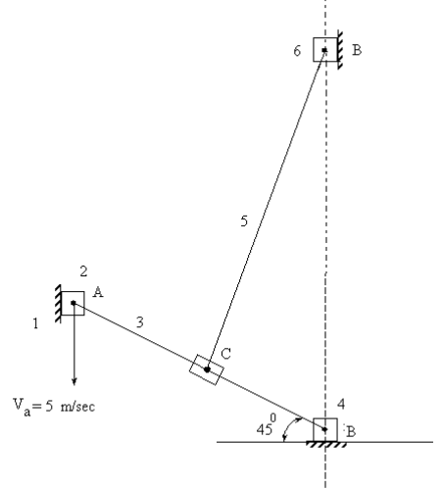  Figure 1
3. |  | Sketch the Davis gear and show that is satisfies the condition for correct steering also explain why Ackermann steering gear is preferred to Davis gear in actual practice. | [15M]
4. |  | A cam rotating clockwise at a uniform speed of 200 r.p.m. is required to move an offset roller follower with a uniform and equal acceleration and retardation on both the outward and return strokes. The angle of ascent, the angle of dwell (between ascent and descent) and the angle of descent is 120°, 60° and 90° respectively. The follower dwells for the rest of cam rotation. The least radius of the cam is 50 mm, the lift of the follower is 25 mm and the diameter of the roller is 10 mm. The line of stroke of the follower is offset by 20 mm from the axis of the cam. Draw the cam profile and find the maximum velocity and acceleration of the follower during the outstroke | [15M]
5. |  | If the interference between two involute gears is to be avoided then prove that the maximum length of arc of contact will be equal to (R+ r) tanφ where R and r = Pitch circle radius of wheel and pinion, φ = Pressure angle. | [15M]
6. |  | An open belt 100 mm wide connects two pulleys mounted on parallel shafts with their centers 2.4 m apart. The diameter of the larger pulley is 450 mm and that of the smaller pulley 300 mm. The coefficient of friction between the belt and the pulley is 0.3 and the maximum stress in the belt is limited to 14 N/mm width. If the larger pulley rotates at 120 r.p.m., find the maximum power that can be transmitted. | [15M]
7. | a) | List any three applications of Hooke’s joint. | [8M]
 | b) | Show that the lengths of the links in Tchebicheff’s mechanism are in proportions  1 : 2 : 2.5 | [7M]
8. |  | An epicyclic gear consists of bevel wheels as shown in Figure 2. The driving pinion A has 20 teeth and meshes with the wheel B which has 25 teeth. The wheels B and C are fixed together and turn freely on the Shaft F. The shaft F can rotate freely about the main axis XX. The wheel C has 50 teeth and meshes with wheels D and E, each of which has 60 teeth. Find the speed and direction of E when A rotates at 200 r.p.m. if 1. D is fixed and 2. D rotates at 100 r.p.m. in the same direction as A.In both the cases, find the ratio of the torques transmitted by the shafts of the wheels A and E, the friction being neglected.  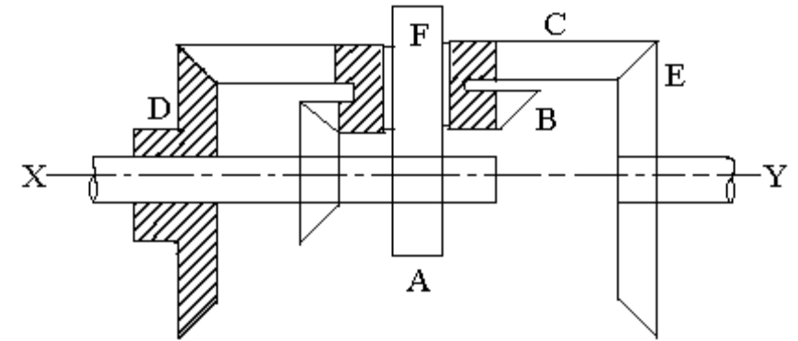  Figure 2 | [15M]

-- 00 -- 00 –

